TELNET (TELECOMMUNICATION NETWORK) :
INTRODUCTION :
- It is one of the application layer protocols as like SSH , used for remote access (using TCP).
- By default, it works on port 23.
- However, telnet is insecure since it doesn’t include any encryption mechanisms thus transmitting the data as plaintext making it vulnerable to security attacks like man in the middle attack.
DEMONSTRATION :
- To enable telnet server in linux, xinetd and telnetd should be installed and it can be started by using sudo systemctl start xinetd as follows: (should yield “Active (running) when status is checked) , can also confirm by checking the port usage using netstat command (uses port 23 by default)

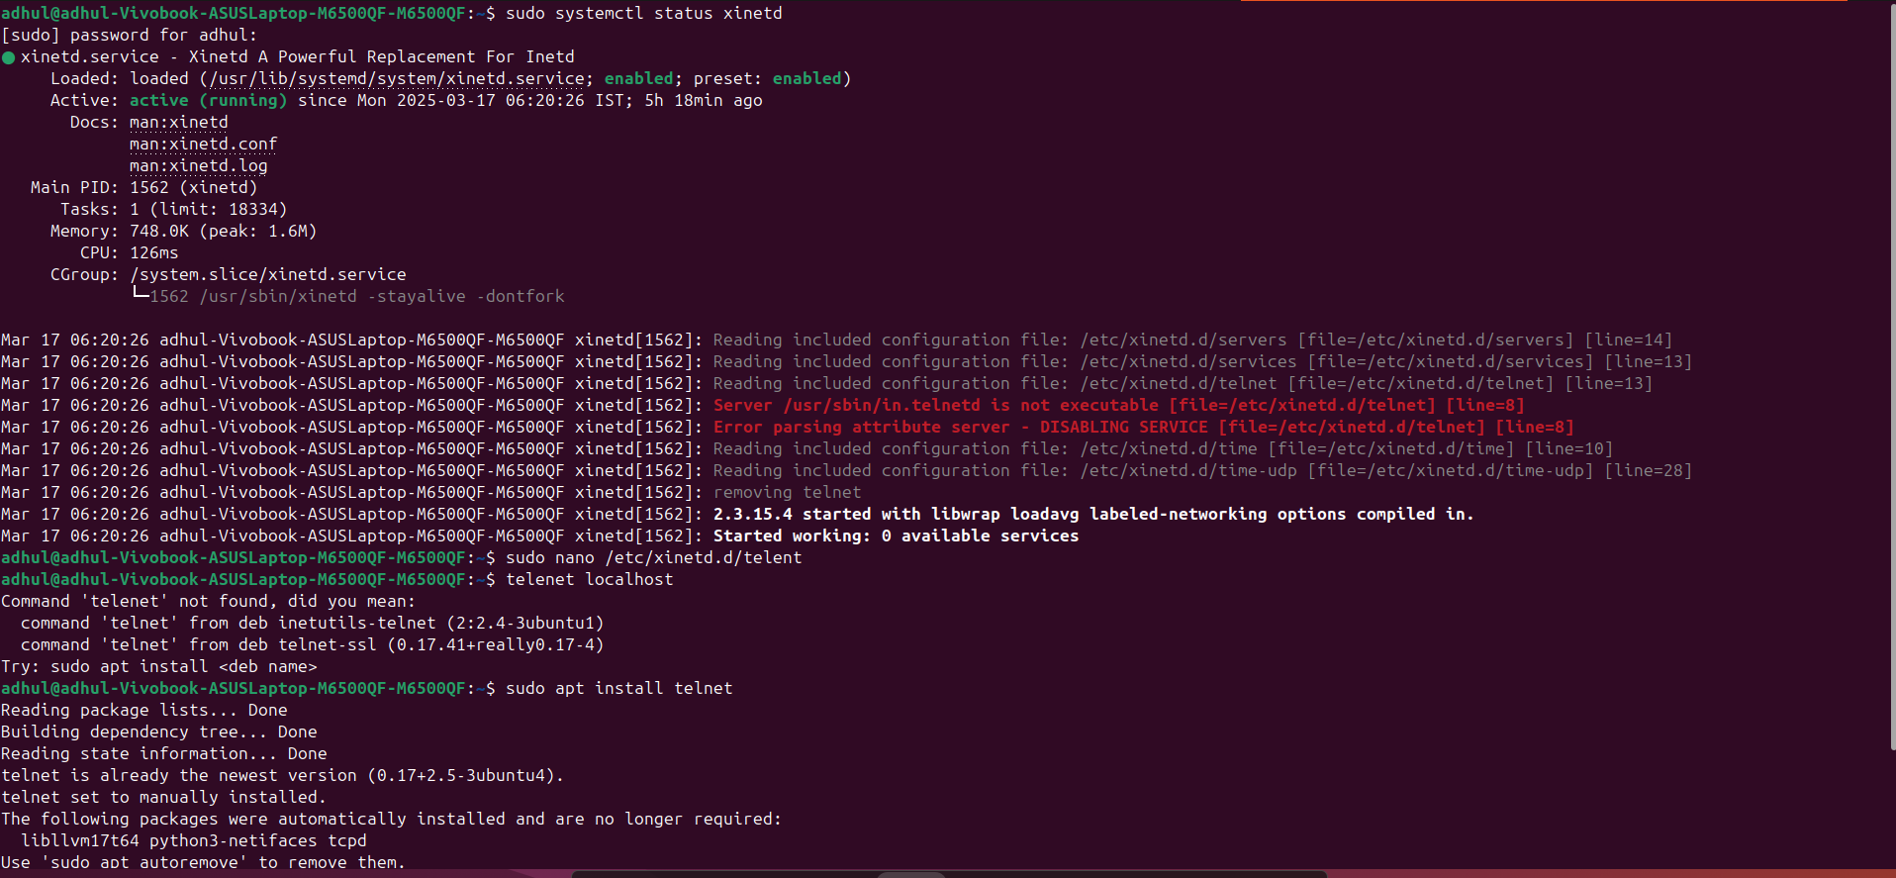

- Now from client machine, (ensure all the above packages are installed), use the following syntax : telnet <IP or hostname> (Here, localhost is demonstrated) as follows:

(It asks for username and password if enabled and will be checked in server side, if matches, then it allows client machine to have remote access to execute commands)

- To exit the session, use “exit” command or ctrl + ‘[‘ in client terminal.

